How to find a file on raspberry pi
Here is an example. To search for files in the /home/pi/files/ directory that begin with the string new, we can use the following command: find /home/pi/files/* -name “new*”
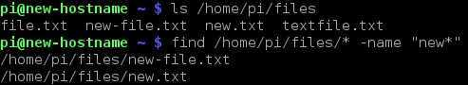
Let’s break down the command:
- find – invokes the find command.
- /home/pi/files/* – specifies the directory that will be searched for the files. The * character specifies that all files inside the /home/pi/files directory will be included in the search.
- -name – specifies that the files will be searched by filename.
- “new*” – the files whose names begin with new will be matched. The expression has to be enclosed in double quotes because of the * character.

Drawing things in OpenCV
https://docs.opencv.org/2.4/modules/core/doc/drawing_functions.html

Coordinates are referenced with (0,0) in the top left coordinate. Increasing going down with positive numbers. Idk why the other eye detection thing works but whatev

